1. Create Purchase Order ME21N

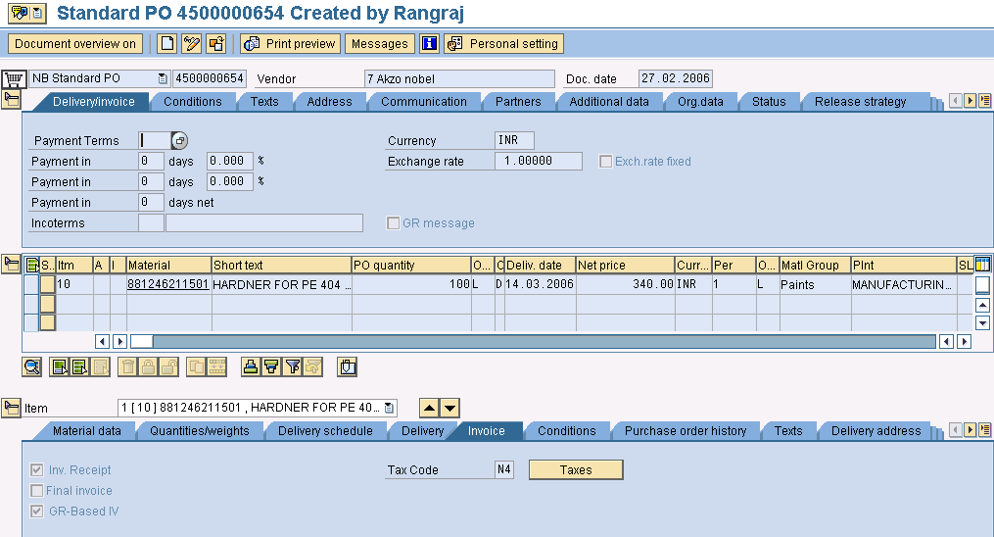

2. Release PO ME29N

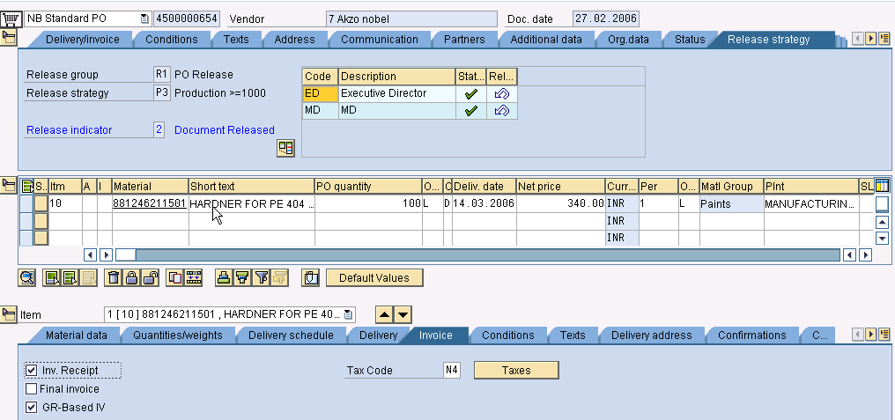

3. Goods Receipt - MIGO

(JMX1 & JEX1 – Condition types for sub-total)

4. Excise Part II Posting – J1IEX

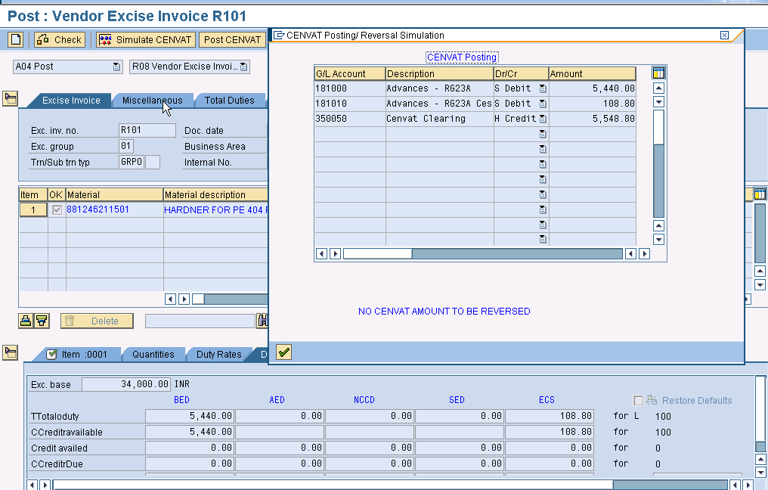

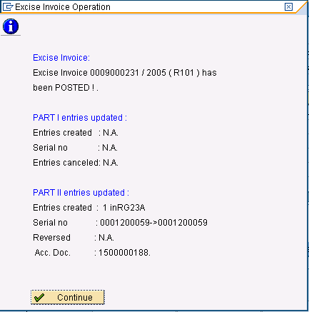

Cancellation Process

5. Return Delivery – MIGO

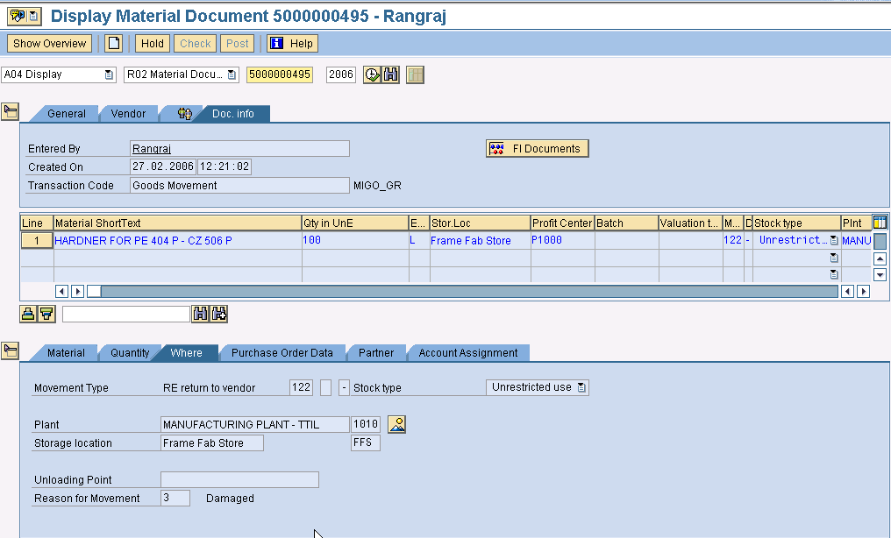

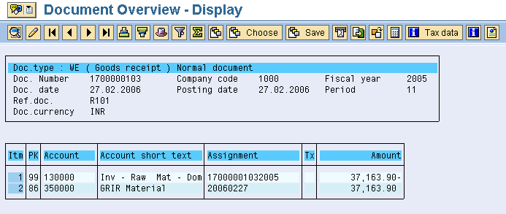

6. Excise Invoice – J1IS (MATD)

7. Release to Accounting – J1IV

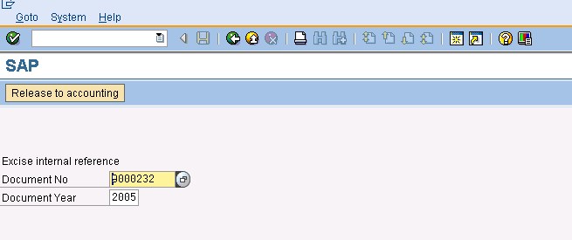

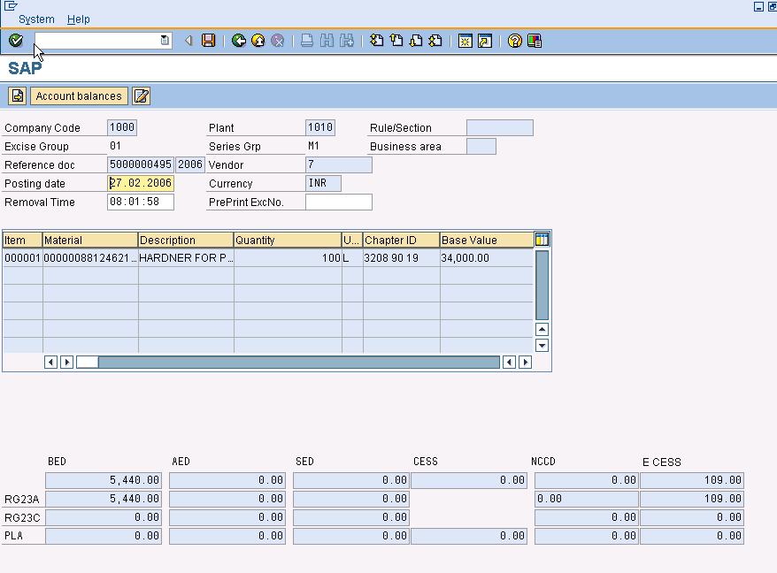

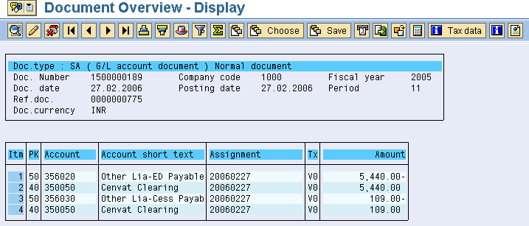

7.Credit Memo – MIRO (Only if MIRO is done earlier)

